Drivers BJT

Motor Driver V1.4

1: Applications

* Bi-directional Motors
* Unidirectional Motors
* High Powered Lighting

2: General

Device utilizes an ATtiny85 microprocessor to drive TLP152 photocouplers which power the base of the BUV26G BJT NPN power transistors.

3: Features

* Output peak voltage: 60V
* Output peak current: 20A
* Output peak wattage: 85W
* Built-in heat dissipation
* Integrated signal processing
* ISP Header
* Reverse external voltage protection

4: Packaging, Pin Assignment, and Indicators

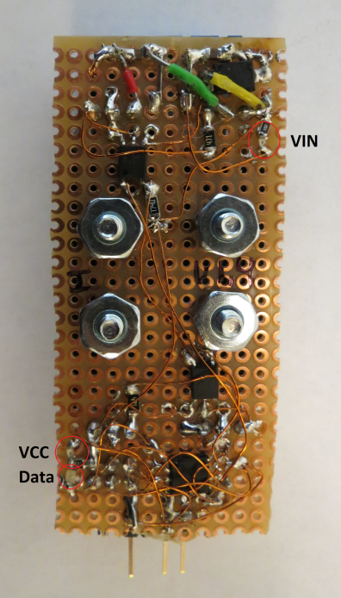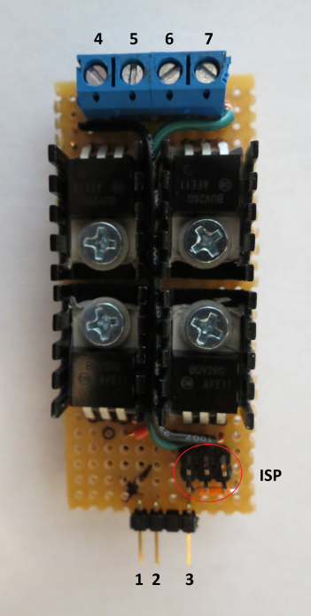

1: GND  
2: VCC (5V)  
3: Data  
4: GND  
5: VIN  
6: OUT -  
7: OUT +

5: Schematic

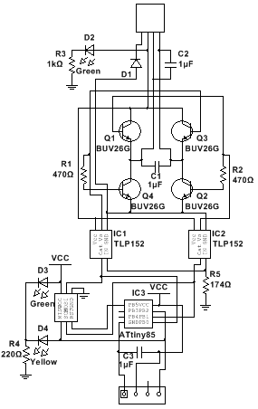

6: Absolute Maximum Ratings

7: Recommended Operating Conditions

8: BOM

9: Package Dimensions